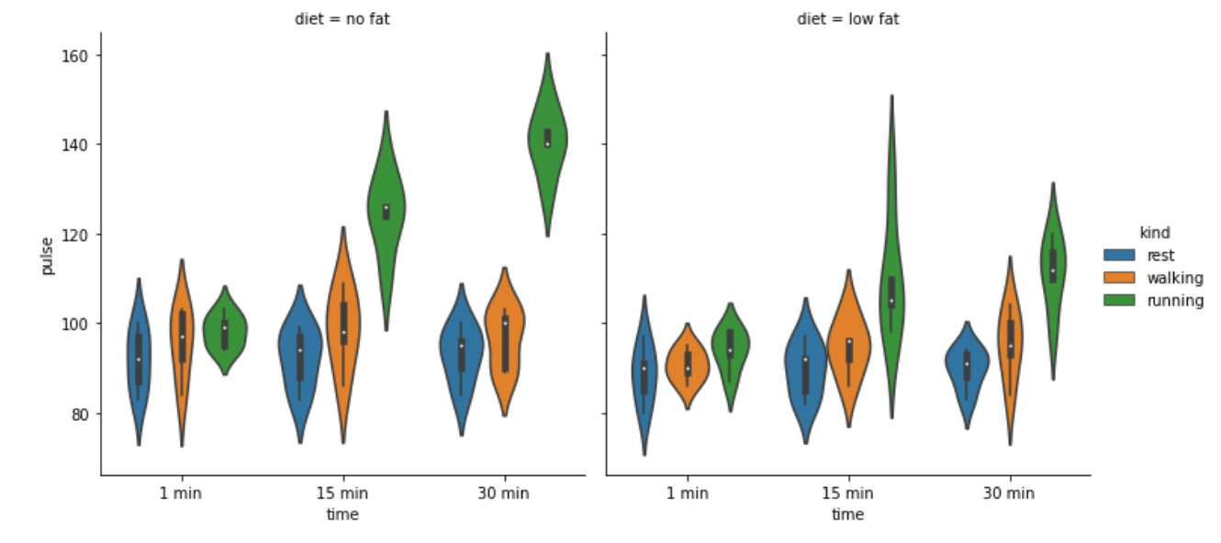

Factor plot is a versatile plotting function in the seaborn library. It allows users to create various categorical plots for data visualization. With Factor plot, we can visualize relationships between variables across different categories.

The syntax for plotting a Factor plot involves specifying the x-axis variable, y-axis variable, dataset, and the kind of plot (e.g., bar plot, box plot, violin plot).

In this graph, the given data shows that x axis -time,y axis-pulse,kind=violin

Here,we are going to analyse the relationship between variables across different categories,

Comparing the column diet with categories fat and low fat with their kind rest,walking,running

DIET =NO FAT (1min,15min,30min)

1 min:

Comparing the column diet with category no fat with their kind rest,walking,running.Here a person who have no fat doing rest for 1min his pulse will be 75 to 110 ,while running 75 to 115,and running 90 to 110.

15min:

Comparing the column diet with category no fat with their kind rest,walking,running .Here a person who have no fat doing rest for 15min his pulse will be 75 to 115,while running 75 to 120,and rest 98to 143.

30min:

Comparing the column diet with category no fat with their kind rest,walking,running.Here a person who have no fat doing walking for 1min his pulse will be 75 to 110 ,while running 78 to 118,and rest 120 to 160.

DIET =LOW FAT (1min,15min,30min)

1min:

Comparing the column diet with categories low fat along with their kind rest,walking,running.Here a person who have no fat doing rest for 1min his pulse will be 75 to 115,while walking 80 to 95,and running 80 to 100.

15min:

Comparing the column diet with category low fat along with their kind rest,walking,running.Here a person who have no fat doing rest for 1min his pulse will be 75 to 110,while walking 75 to 115,and running 78 to 150.

30min:

Comparing the column diet with category no fat and low fat along with their kind rest,walking,running.Here a person who have no fat doing rest for 1min his pulse will be 75 to 100 ,while walking 73 to 115,and running 85 to 130.